Lesson 8 Demo 2: Create a Service to Route Traffic from Frontend to Backend Pods

This section will guide you to:

* Create a Service to Route Traffic from Frontend to Backend Pods

**Step 1:** Create an nginx deployment and scale it to two pods

* Use the following command to create an nginx deployment and scale it to two pods

*kubectl create deployment nginx --image=nginx*

*kubectl scale --replicas=2 deployment/nginx*

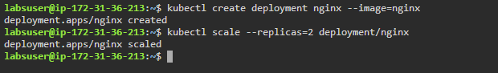

* List all the newly created pods

*kubectl get pods*

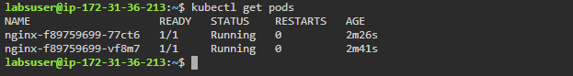

**Note:** These nginx pods will act as the backend application

**Step 2:** Create a service that can communicate with the backend pods

* Create a **service.yaml** file to create a service

*vi service.yaml*



* Add the following code in the **service.yaml** file

*kind: Service*

*apiVersion: v1*

*metadata:*

*name: service-demo*

*spec:*

*ports:*

*- port: 8080*

*targetPort: 80*

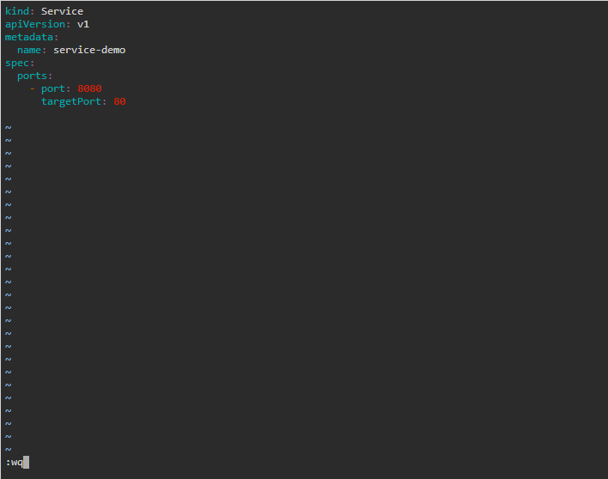

* Create the service from the service.yaml file and list the services

*kubectl apply -f service.yaml*

*kubectl get service*

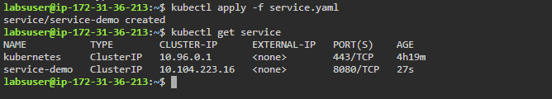

**Step 3:** Create an endpoint to send traffic from the service to the backend pods

* Get the IP address of the pod you wish to add as an endpoint

*kubectl get pods -o wide*

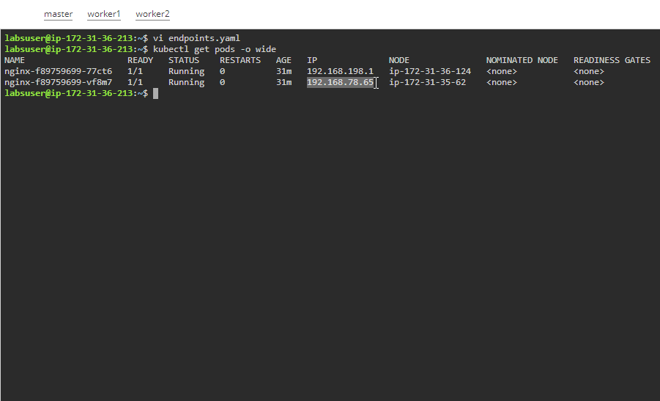

* Create an endpoint.yaml file to create an endpoint

*vi endpoints.yaml*

**

* Add the following code in the **endpoint.yaml** file

*apiVersion: v1*

*kind: Endpoints*

*metadata:*

*name: service-demo*

*subsets:*

*- addresses:*

*- ip: 192.168.78.65*

*ports:*

*- port: 80*

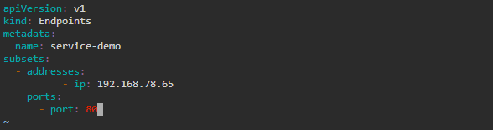

* Create the endpoint from the endpoint.yaml file and list the endpoints

*kubectl apply -f endpoint.yaml*

*kubectl get endpoint*

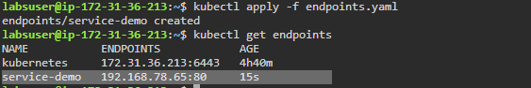

* Check the newly created service for the endpoint added to it

*kubectl describe service service-demo*

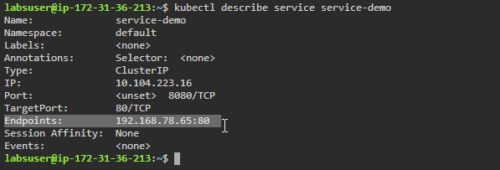

**Step 4:** Create a frontend pod and connect it to the backend pods using the newly created service

* List the services and copy the **Cluster-IP** of the service created along with its port

*kubectl get service*

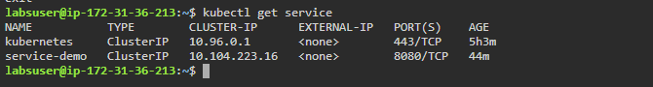

* Use the **ubuntu** image to create the frontend pod

*kubectl run -it ubuntu --image=ubuntu*

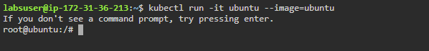

* Use the following commands to install curl

*apt update*

*apt install curl*

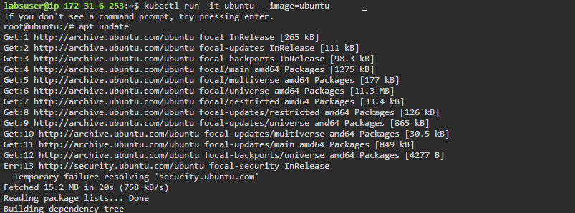

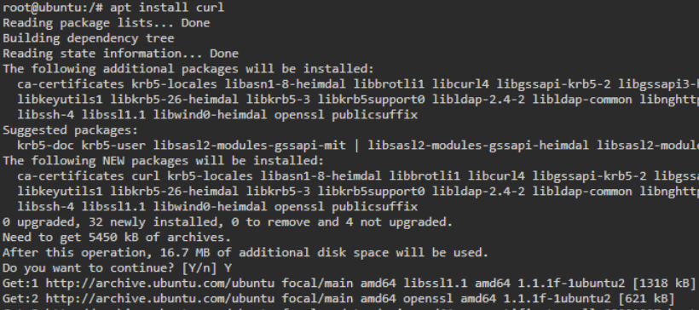

* Connect to the backend pod using the service and dedicated endpoint using the **curl** command

*curl <Service-Cluster-IP>:<Service-Port>*

